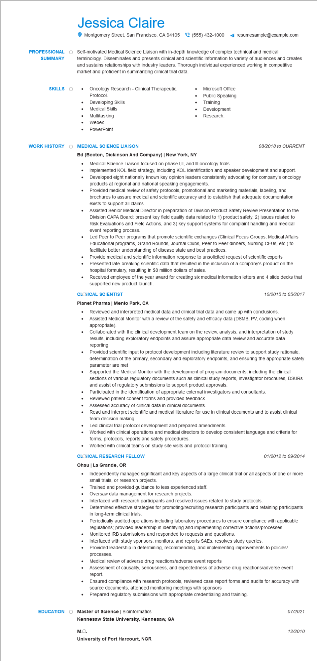
PROFESSIONAL
SUMMARY
SKILLS
Jessica Claire
Montgomery Street, San Francisco, CA 94105 (555) 432-1000
resumesample@example.com
Self-motivated Medical Science Liaison with in-depth knowledge of complex technical and medical terminology. Disseminates and presents clinical and scientific information to variety of audiences and creates and sustains relationships with industry leaders. Thorough individual experienced working in competitive market and proficient in summarizing clinical trial data.
Oncology Research - Clinical Therapeutic,
Protocol.
Developing Skills
.
Medical Skills
Multitasking
•
Webex
PowerPoint
•
Microsoft Office
Public Speaking Training
Development Research.
WORK HISTORY
MEDICAL SCIENCE LIAISON
Bd (Becton, Dickinson And Company) | New York, NY
•
08/2018 to CURRENT
Medical Science Liaison focused on phase I,II, and III oncology trials. Implemented KOL field strategy, including KOL identification and speaker development and support. Developed eight nationally known key opinion leaders consistently advocating for company's oncology products at regional and national speaking engagements.
Provided medical review of safety protocols, promotional and marketing materials, labeling, and brochures to assure medical and scientific accuracy and to establish that adequate documentation exists to support all claims.
Assisted Senior Medical Director in preparation of Division Product Safety Review Presentation to the Division CAPA Board: present key field quality data related to 1) product safety, 2) issues related to Risk Evaluations and Field Actions, and 3) key support systems for complaint handling and medical event reporting process.
Led Peer to Peer programs that promote scientific exchanges (Clinical Focus Groups, Medical Affairs Educational programs, Grand Rounds, Journal Clubs, Peer to Peer dinners, Nursing CEUs, etc.) to facilitate better understanding of disease state and best practices.
Provide medical and scientific information response to unsolicited request of scientific experts Presented late-breaking scientific data that resulted in the inclusion of a company's product on the hospital formulary, resulting in $8 million dollars of sales.
Received employee of the year award for creating six medical information letters and 4 slide decks that supported new product launch.
CLOVICAL SCIENTIST
Planet Pharma | Menlo Park, CA
10/2015 to 05/2017
• Reviewed and interpreted medical data and clinical trial data and came up with conclusions.
•
•
•
•
Assisted Medical Monitor with a review of the safety and efficacy data (DSMB, PV, coding when appropriate).
Collaborated with the clinical development team on the review, analysis, and interpretation of study results, including exploratory endpoints and assure appropriate data review and accurate data reporting
Provided scientific input to protocol development including literature review to support study rationale, determination of the primary, secondary and exploratory endpoints, and ensuring the appropriate safety parameter are met
Supported the Medical Monitor with the development of program documents, including the clinical sections of various regulatory documents such as clinical study reports, investigator brochures, DSURS and assist of regulatory submissions to support product approvals.
Participated in the identification of appropriate external investigators and consultants. Reviewed patient consent forms and provided feedback.
Assessed accuracy of clinical data in clinical documents.
Read and interpret scientific and medical literature for use in clinical documents and to assist clinical team decision making
Led clinical trial protocol development and prepared amendments.
Worked with clinical operations and medical directors to develop consistent language and criteria for forms, protocols, reports and safety procedures.
Worked with clinical teams on study site visits and protocol training.
CLOVICAL RESEARCH FELLOW
Ohsu | La Grande, OR
•
01/2012 to 09/2014
Independently managed significant and key aspects of a large clinical trial or all aspects of one or more small trials, research projects.
Trained and provided guidance to less experienced staff.
Oversaw data management for research projects.
Interfaced with research participants and resolved issues related to study protocols.
Determined effective strategies for promoting/recruiting research participants and retaining participants in long-term clinical trials.
Periodically audited operations including laboratory procedures to ensure compliance with applicable regulations; provided leadership in identifying and implementing corrective actions/processes. Monitored IRB submissions and responded to requests and questions.
Interfaced with study sponsors, monitors, and reports SAES; resolves study queries.
Provided leadership in determining, recommending, and implementing improvements to policies/ processes.
Medical review of adverse drug reactions/adverse event reports
Assessment of causality, seriousness, and expectedness of adverse drug reactions/adverse event report.
Ensured compliance with research protocols, reviewed case report forms and audits for accuracy with source documents, attended monitoring meetings with sponsors
•
Prepared regulatory submissions with appropriate credentialing and training.
EDUCATION
Master of Science | Bioinformatics
Kennesaw State University, Kennesaw, GA
M.O.
University of Port Harcourt, NGR
07/2021
12/2010

